Library Management System
Documentation

INDEX
1. Problem Definition 3
1.1. Problem Abstraction 3
1.2. The Current System 3
1.3. The Proposed System 3
1.4. Boundaries of the System 3
1.5. Hardware and Software Requirements 3
1.5.1. Minimum Requirements 3
1.5.2. Recommended Requirements 3
2. Customer Requirements Specification 4
2.1. Users of the System 4
2.2. System functions 4
3. Architecture and Design of Project 5
3.1. Data Flow Diagram 5
3.2. Entity Relationship Diagram(Table Design) 5
3.3. Database Structure 5
3.4. Screen Design 5
4. Task Sheet 6
5. Checklists 7
5.1. Check List of Validation 7
5.2. Submission Checklist 7

Problem Definition

Problem Abstraction
To day, business manages system to require the effect and to economize time .First and foremost in business manages library book of a company .Therefore we present sofware to manage library book of the Mohan Ltd company.

The Current System
Mohan Ltd. has a library which is managed by Ms. Monica manually. All records are on paper and Monica finds it very difficult to manage when somebody issues or returns the books. She has to maintain list of books along with details such as Author name, book title etc. When a book is to be issued, she has to manually search for that book and again for issuing book she has to maintain a register which will have details of book issued such as Name of the book, Author, Employee details (name, department etc) , Date of issue, Date of return, etc. This process is tedious and time consuming. She has brought it to the notice of her seniors and they have proposed the solution of developing a system which will help Monica managing the things more effectively and also save her time. She will be the only user of the system.

The Proposed System
- Software Library Management Book of we will help to Ms. Monica, can manage book have library same manage business borrow and return book.

Boundaries of the System
Boundaries of system will built:

- Software Library Management Book of we, have size small only use to a company.

Hardware and Software Requirements

Minimum Requirements

Minimum
PC Pentium II 600 MHz
128MB RAM
500 MB hard drive

Recommended Requirements

Preferred
PC Pentium III 1800 MHz
2G RAM
2 GB hard drive

Software
Software:

-JDK 1.6
-Netbean 6.1
-Sql server 2005

2. Customer Requirements Specification

Users of the System
The object influence system include:

- User

System functions

Function User
- Add, edit Employee

Description | User add, edit employee.
Input | -Employee ID.  -Name.  -Address.  -Phone Number.  -Department.  -EmployStatus.
Process | Update data in database when add, edit employee.
Output | Display employee edit và employee new.
- Delete Employee

Description | User delete employee.
Input | -Employee ID.
Process | Update data in database when delete employee.
Output | Display announcement you deleted successful.

- Add, edit Book

Description | User add, edit book.
Input | -Book ID.  -CallNumber(XX-XX-XXX)  -ISBN.(XXX-XXXX)  -Title.  -Phone Number.  -PubHouse.
Process | Update data in database when add, edit book.
Output | Display book edit và book new.

- Delete Book

Description | User delete book.
Input | -Book ID.
Process | Update data in database when delete book.
Output | Display announcement you deleted successful.

- Add, edit, delete User

Description | User add, edit, delete user.
Input | -User ID.  -Name.  -User Status.
Process | Update data in database when add, edit, delete user.
Output | Display user edit và user new.

- Search Book

Description | User search book.
Input | -Call number.(XX-XX-XXX)  -ISBN number.(XXX-XXXX)  -Title.  -Author
Process | Access data from database and to take information book satisfy require search.
Output | -If have book then display information book where User search.  -If not have book then display announcement

- Check Out

Description | User give Employee borrow book ,search book.
Input | -Call number.  -ISBN number.  -Title.  -Author.  -Employee ID
Process | Update data in database when librarian add the ballok give borrow book.
Output | -Display result the ballok borrow book.

- Check In

Description | User agree the book return from Employee, search Employee Name.
Input | -Date borrow.  -Date due.  -Employee Name.
Process | Access data from database and to take information the ballok give borrow book, compare the due date and return date if The Employee keep a borrowed book in excess of the time limit then Employee was punish 10 cent each day.
Output | -Display result the ballok give the book return.

- Display information detail book

Description | Function give the librarian see the book detail.
Input | -Choose the book need see.
Process | To take the information book from database.
Output | -Display the information require.

- Display information detail employee

Description | Function give the librarian see the book detail.
Input | -Choose the Employee need see.
Process | To take the information book from database.
Output | -Display the information require.

- Log in

Description | To allow the librarian log in.
Input | -UserName and Password.
Process | Check UserName and Password in database.
Output | -Display the result log in.

- Log out

Description | To allow the librarian log out.
Input | - UserName and Password.
Process | Check UserName and Password in database.
Output | -Display the result log out.

Architecture & Design of Project

Data Flow Diagram
Level 0:
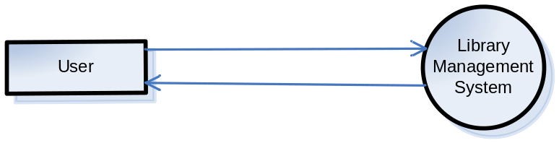
Level 1:

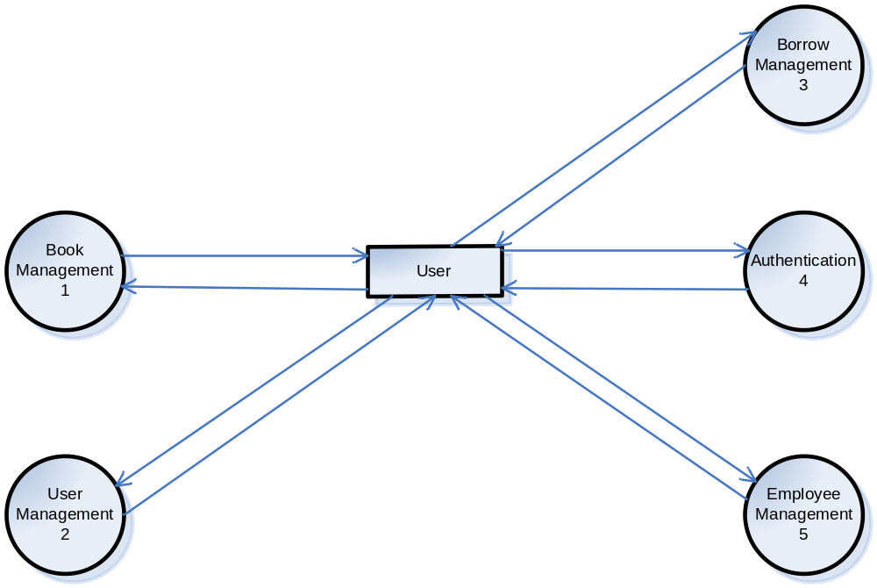

Level 2:

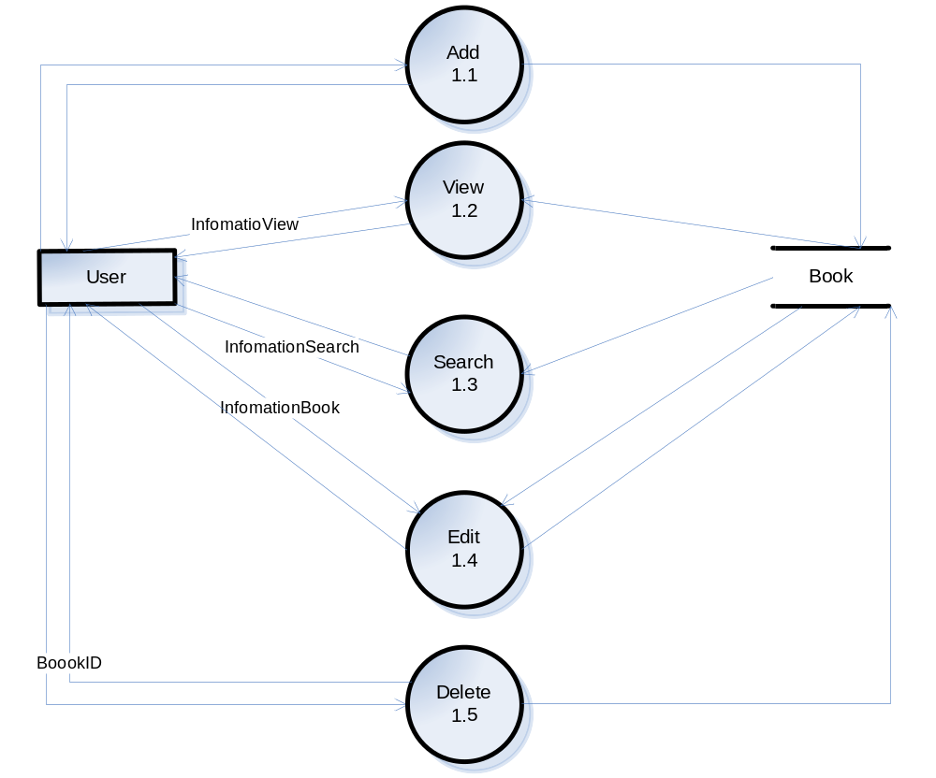
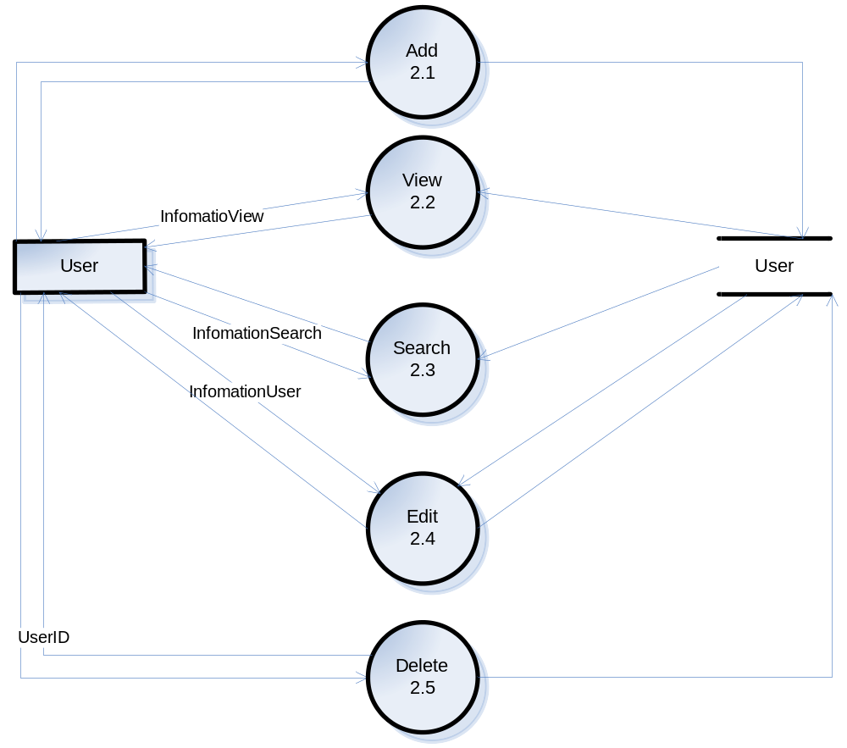

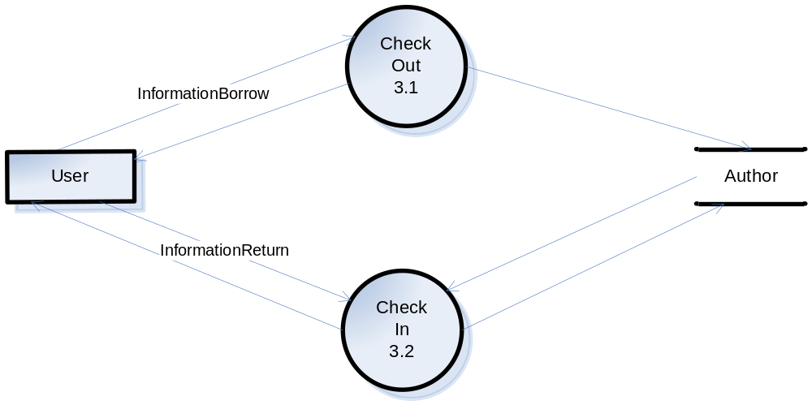

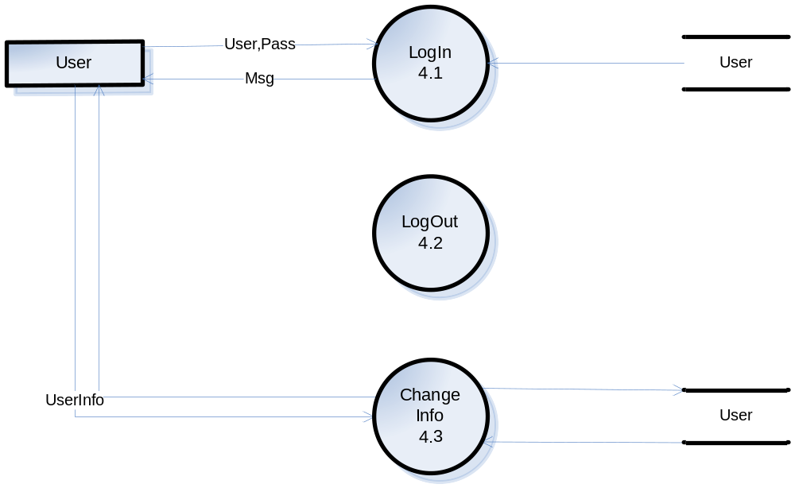

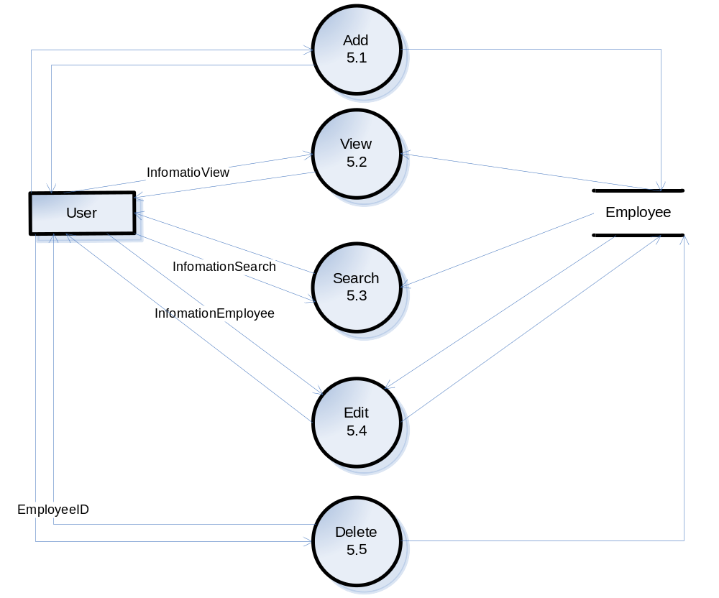

Level 3:
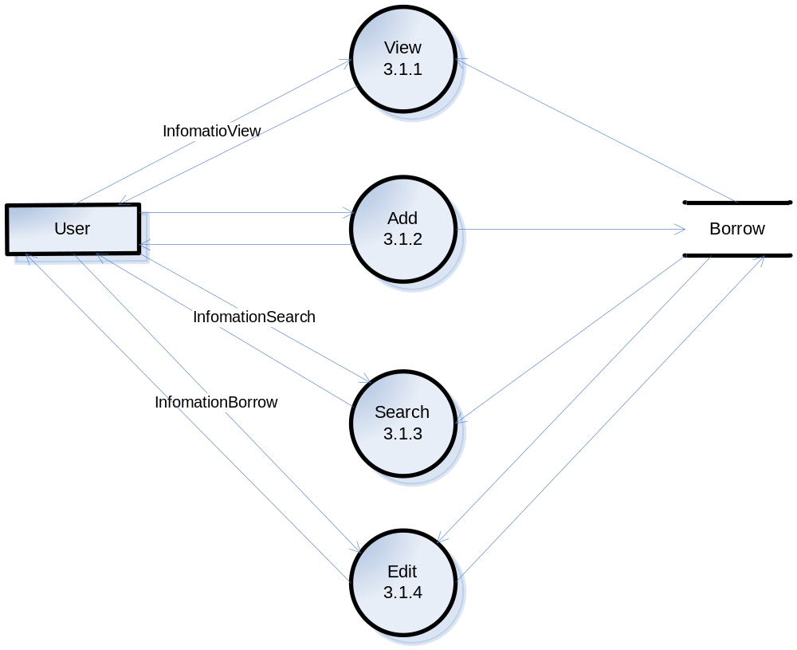

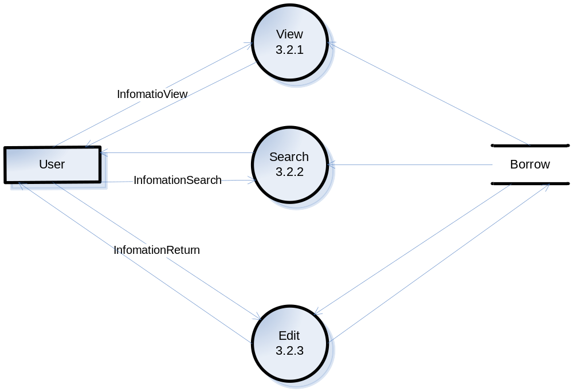

Entity Relationship Diagram (Table Design)
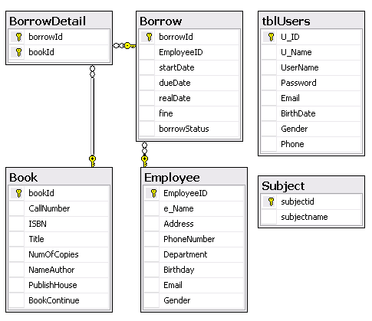

Database Structure
3.3.1. Borrow
Fields | Type | Size | Constraint | Description
BorrowId | int | 4 | Primay key, identity(1,1) | Code ballok book borrow
StartDate | datetime |  | Default getdate() | Day book borrow
DueDate | datetime |  | Default getdate() | Day appoint book return
RealDate | datetime |  | Default getdate() | Day book return
File | int |  | check>=0 | Number money punish
BorrowStatus | bit |  | Default 0 | Status ballok
EmployeeID | int | 4 | Foreign key, not null | Code Employee

3.3.2. Book
Fields | Type | Size | Constraint | Description
BookId | int | 4 | Primay key, identity(1,1) | Code book
CallNumber | varchar | 50 | Not null
ISBN | varchar | 50 | Not null
Title | nvarchar | 100 | Not null | Title of book
NumOfCopies | int |  | check>=0 | Number book copies
NameAuthor | varchar | 50 | not null | Name author
PublishHouse | varchar | 50 | not null | Name Publish House
NumOfContinue | int |  | check>=0 | Number book continue

3.3.3.BorrowDetail
Fields | Type | Size | Constraint | Description
BorrowID | int | 4 | Primay key, identity(1,1), Foreign key, not null | Code ballok book borrow
BookID | int | 4 | Primay key, identity(1,1), Foreign key, not null | Code book

3.3.4.Employee:

Fields | Type | Size | Constraint | Description
EmployeeId | int | 4 | Primay key, identity(1,1) | Code Employee
Name | nvarchar | 50 | Not null | Name Employee
Address | varchar | 50 | Not null | Address Employee
PhoneNumber | varchar | 50 | Not null | Phone Employee
Department | nvarchar | 50 | check>=0 | Department company
Gender | bit |  | Default 0 | Store gender of user  If = 0 : Female  If = 1 : Male

3.3.5.User

Field Name | Data Type | Null | Key | Description
U_ID | Int | No | PK | Store ID of user
U_Name | Varchar(30) | No |  | Store name of user
UserName | Varchar(30) | No |  | Store username of user
Password | Varchar(32) | No |  | Store password of user
Email | Varchar(50) | Yes |  | Store email of user
BirthDate | Datetime | Yes |  | Store user ’s birthday
Gender | Bit | Yes |  | Store gender of user  If = 0 : Female  If = 1 : Male
Phone | Varchar(20) | Yes |  | Store phone of user

3.3.6.Subject
Fields | Type | Size | Constraint | Description
SubjectID | int | 4 | Primay key, not null | Store code subject
SubjectName | nvarchar | 450 | not null | Store name subject

Screen Design

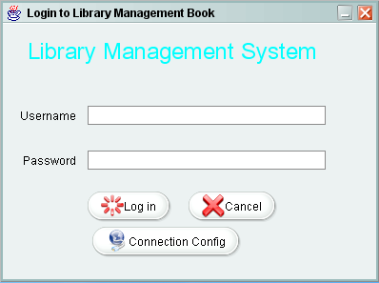
Login

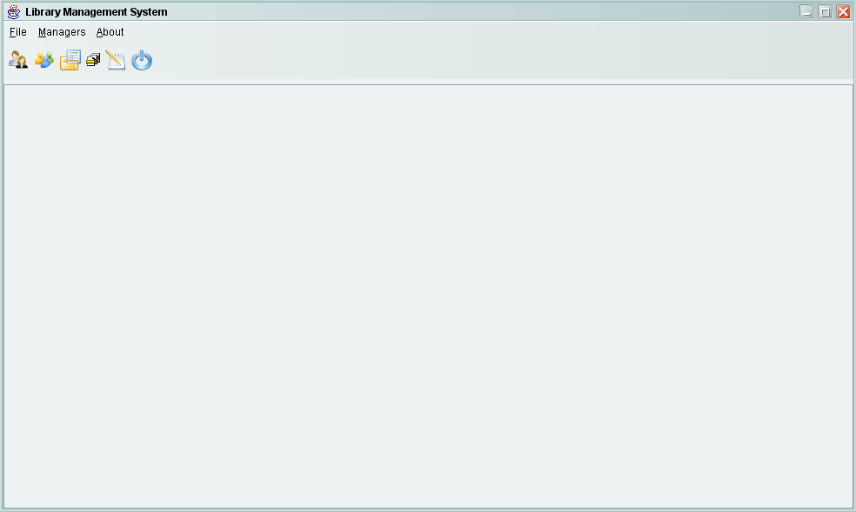
Home
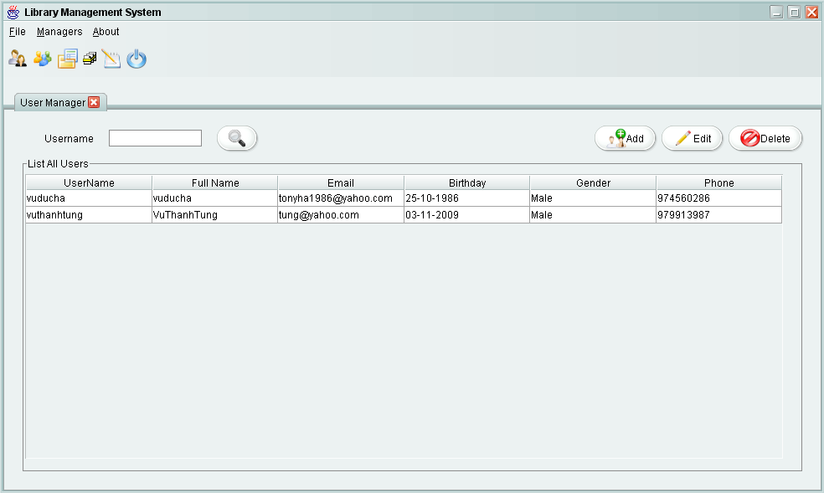
USER MANAGER

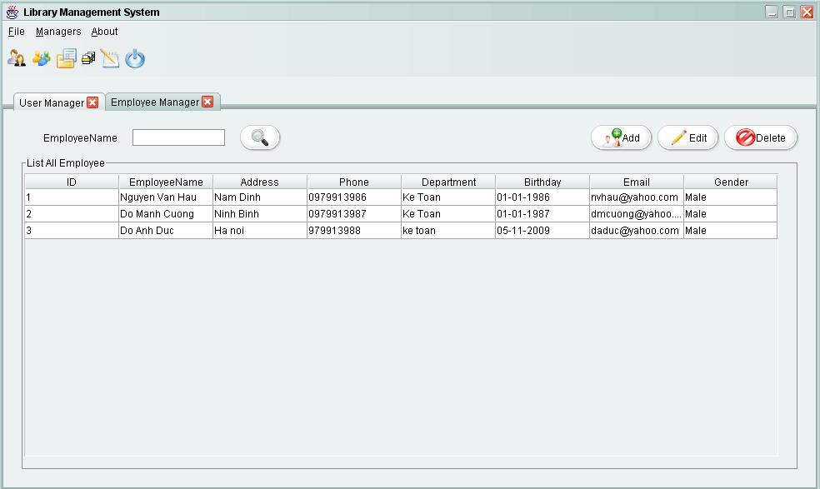
EMPLOYEE MANAGER

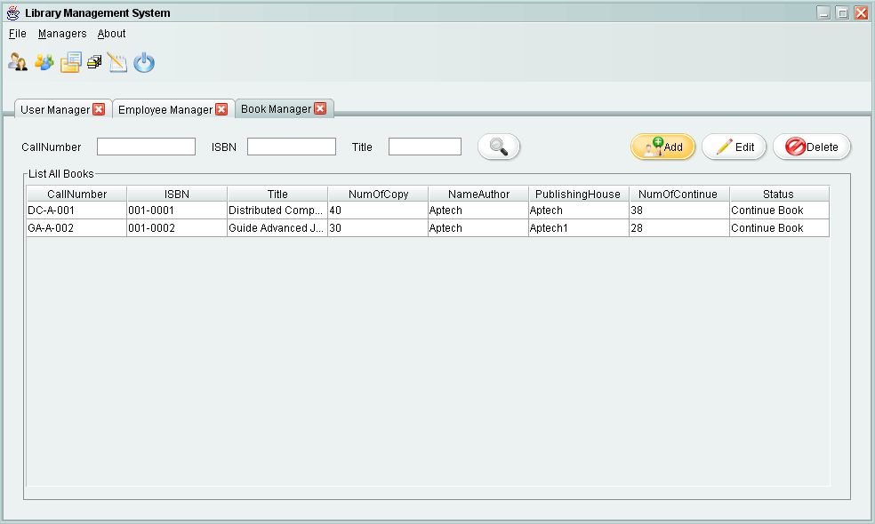
BOOK MANAGER

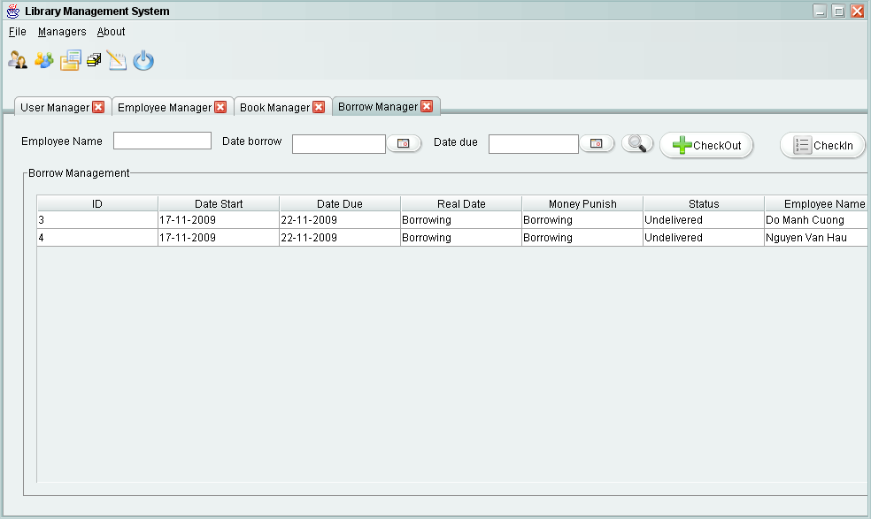
BORROW MANAGER

